Learner Guide

Module 7 – Artificial Intelligence
Occupational Certificate: Artificial Intelligence Software Developer

Module # | 251201-002-00-KM-07
NQF Level | 5
Notional hours | 120
Credit(s) | 12
Curriculum Code | 251201002
Qualification Title | Occupational Certificate: Artificial Intelligence Software Developer
Development  Quality Partner | MICT SETA
Occupation or Specialization | AI Software Developer
Associated Occupation | Software Developer

CONTACT INFORMATION:
Name
Contact Address
Telephone (H)
Telephone (W)
Facsimile
Cellular
E-mail

Note to the learner
This Learner Guide provides a comprehensive overview of the module. It is designed to improve the skills and knowledge of learners, and thus enabling them to effectively and efficiently complete specific tasks.
PURPOSE OF THE KNOWLEDGE MODULE
The main focus of the learning in this knowledge module is to build an understanding of artificial Intelligence, its definition and future, as well as the purpose and contribution of AI to society and business

Entry Requirements:
NQF 4

PROVIDER ACCREDITATION REQUIREMENTS FOR THE MODULE:

Physical Requirements:
The provider must have lesson plans and structured learning material or provide learners with access to structured learning material that addresses all the topics in all the knowledge modules as well as the applied knowledge in the practical skills.
QCTO/ MICT SETA requirements
Human Resource Requirements:
Lecturer/learner ratio of 1:20 (Maximum)
Qualification of lecturer (SME):
NQF 6 in industry recognised qualifications with 1 year’s experience in the IT industry
AI vendor certification (where applicable)
Assessors and moderators: accredited by the MICT SETA
Legal Requirements:
Legal (product) licences to use the software for learning and training (where applicable)
OHS compliance certificate
Ethical clearance (where necessary)
Exemptions
No exemptions, but the module can be achieved in full through a normal RPL process

Assessments:

The only way to establish whether you are competent and have accomplished the learning outcomes is through continuous assessments. This assessment process involves interpreting evidence about your ability to perform certain tasks. You will be required to perform certain procedures and tasks during the training programme and will be assessed on them to certify your competence.

This module includes assessments in the form of self-evaluations/activities and exercises. The exercises, activities and self-assessments will be done in pairs, groups or on your own. These exercises/activities or self-assessments (Learner workbook) must be handed to the facilitator. It will be added to your portfolio of evidence, which will be proof signed by your facilitator that you have successfully performed these tasks.

Listen carefully to the instructions of the facilitator and do the given activities in the time given to you.

TOPIC ELEMENTS TO BE COVERED INCLUDE:

KM-07-KT01 : AI frameworks
KM-07-KT02 : Using AI for data scraping

SECTION 1: KM-07-KT01:AI frameworks
Learning Outcome
- KT0101 Introduction to AI frameworks
- KT0102 Advantages and disadvantages of frameworks:
    - TensorFlow -- TensorFlow Lite
    - Theano -- Lasagne
    - Keras
    - Torch -- PyTorch
    - IBM Watson -- Watson IoT
    - Amazon Web Services (AWS) -- Amazon Lex, Amazon Translate & Amazon Polly
- KT0103 Fundamentals of each framework
    - What application is best suitable for a specific context
    - Applied knowledge of frameworks
- KT0104 Demonstration of each framework

- KT0101 Introduction to AI frameworks
AI frameworks provide data scientists, AI developers, and researchers the building blocks to architect, train, validate, and deploy models, through a high-level programming interface.

What is a framework in machine learning?
A machine learning framework is an interface that allows developers to build and deploy machine learning models faster and easier. A tool like this allows enterprises to scale their machine learning efforts securely while maintaining a healthy ML lifecycle.

What is Introduction to AI?



Artificial Intelligence is an approach to make a computer, a robot, or a product to think how smart human think. AI is a study of how human brain think, learn, decide and work, when it tries to solve problems.

- KT0102 Advantages and disadvantages of frameworks:
    - TensorFlow -- TensorFlow Lite
    - Theano -- Lasagne
    - Keras
    - Torch -- PyTorch
    - IBM Watson -- Watson IoT
    - Amazon Web Services (AWS) -- Amazon Lex, Amazon Translate & Amazon Polly

What are the advantages of using a framework?

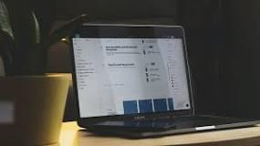

Below are the key benefits of using frameworks to develop online programs.
- Makes easier the Development Process. The frameworks provide the tools and packages to help people start developing their websites. ...
- Eases Debugging and Application Maintenance. ...
- Reduces Code Length. ...
- Improves Database Proficiency. ...
- Reinforces security.

Is TensorFlow Lite same as TensorFlow?

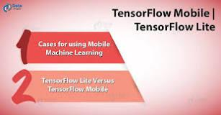

The differences between TensorFlow Lite and TensorFlow Mobile are as follows: It is the next version of TensorFlow mobile. Generally, applications developed on TensorFlow Lite will have better performance and less binary file size than TensorFlow mobile.

What is Theano and lasagne?
Lasagne is a lightweight library to build and train neural networks in Theano. Its main features are: Supports feed-forward networks such as Convolutional Neural Networks (CNNs), recurrent networks including Long Short-Term Memory (LSTM), and any combination thereof.

What is the uses of Keras?
Applications of Keras
Keras is used for creating deep models which can be productized on smartphones. Keras is also used for distributed training of deep learning models. Keras is used by companies such as Netflix, Yelp, Uber, etc.

Is Torch and PyTorch same?
Common Origin. Initially, Torch was developed and later, PyTorch was developed as a Python implementation of Torch. Both frameworks have been developed by Facebook. Both are open source.

Is Torch part of PyTorch?
PyTorch defines a class called Tensor ( torch. Tensor ) to store and operate on homogeneous multidimensional rectangular arrays of numbers. PyTorch Tensors are similar to NumPy Arrays, but can also be operated on a CUDA-capable Nvidia GPU. PyTorch supports various sub-types of Tensors.

What are Amazon Polly Amazon transcribe and Amazon translate services used for?
Amazon Polly is a text-to-speech service that uses advanced deep-learning technologies to synthesize speech that sounds like a human voice. With it, you can create applications that talk, and you can build entirely new categories of speech-enabled products.

Does Amazon Lex use Polly?
Polly NTTS voices deliver advanced improvements in speech quality through a new machine learning approach. Amazon Lex is natively integrated with Amazon Polly for voice interactions. Until today, Lex developers could only configure bots to use Polly's standard Text-to-Speech (TTS) voices.

What is Amazon Polly used for?
Amazon Polly is a service that turns text into lifelike speech, allowing you to create applications that talk, and build entirely new categories of speech-enabled products. Polly's Text-to-Speech (TTS) service uses advanced deep learning technologies to synthesize natural sounding human speech.

- KT0103 Fundamentals of each framework
    - What application is best suitable for a specific context
    - Applied knowledge of frameworks

What is context framework?
The contextual framework involves literature-based claims on how problems are addressed by referring to various countries, cultural backgrounds, beliefs, moral values and organisational structures.

What are the 4 theoretical frameworks?
This lesson will briefly cover the four major theories in sociology, which are structural-functional theory, social conflict theory, feminism, and symbolic interactionism theory.

What are 3 components of a theoretical framework?

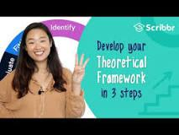

To build your theoretical framework, follow these three steps.
- Identify your key concepts. The first step is to pick out the key terms from your problem statement and research questions. ...
- Evaluate and explain relevant theories. ...
- Show how your research fits in.

What is a framework for learning?

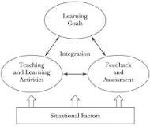

Teaching and learning frameworks are research-informed models for course design that help instructors align learning goals with classroom activities, create motivating and inclusive environments, and integrate assessment into learning.

What are the four frameworks of good teaching?
Lesson Summary
The Framework for Teaching is a set of components that outlines a teacher's responsibilities. It's divided into four domains: (1) Planning and Preparation, (2) Classroom Environment, (3) Instruction and (4) Professional Responsibilities.

What makes a framework effective in teaching and learning process?
With instructional frameworks, teachers gain the knowledge and tools needed to create meaningful relationships with students, energize lessons, enhance the learning environment, build motivation and improve attitude, increase cognitive capacity, and champion high expectations.

What are the key components of the framework for 21st century learning?

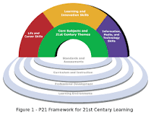

The skills have been grouped into three main areas:
- Learning and innovation skills: critical thinking and problem solving, communications and collaboration, creativity and innovation.
- Digital literacy skills: information literacy, media literacy, Information and communication technologies (ICT) literacy.

- KT0104 Demonstration of each framework
What is a framework of a study?
The theoretical framework is the structure that can hold or support a theory of a research study. The theoretical framework introduces and describes the theory that explains why the research problem under study exists.

How do you prepare framework?

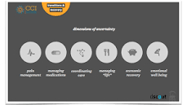

- A framework is the basic structure of something. ...
- Identify categories of information as the basis of your framework. ...
- The second step in creating a good framework is to develop a way to represent the list visually. ...
- Start creating design frameworks to improve your team's ability to solve complex problems.

What is included in a framework?
A framework may be for a set of functions within a system and how they interrelate; the layers of an operating system; the layers of an application subsystem; how communication should be standardized at some level of a network; and so forth.

What is a framework model?
A framework is an entity between a 'model' and a 'method'. A framework is, or contains, a (not completely detailed) structure or system for the realization of a defined result/goal. Many frameworks comprise one or more models, based on the modelling techniques mentioned above and often based on (best) practices.

Internal Assessment Criteria and Weight

- IAC0101 Artificial Intelligence frameworks are understood and described
- IAC0102 Advantages and disadvantages of AI frameworks are understood and described
- IAC0103 Fundamentals of AI frameworks are understood, described and demonstrated

SECTION 2: KM-07-KT02: Using AI for data scraping
Learning Outcome
- KT0201 Concept and definition
- KT0202 Purpose of data scraping
- KT0203 Data scraping tools
- KT0204 Legal issues
- KT0205 Web scraping procedure:
    - Find the URL to scrape
    - Inspect the page
    - Find the data you want to extract
    - Write the code
    - Run the code and extract the data
    - Store the data in the required format
- KT0206 Libraries used for web scraping

- KT0201 Concept and definition
Web scraping involves writing a software robot that can automatically collect data from various webpages. Simple bots might get the job done, but more sophisticated bots use AI to find the appropriate data on a page and copy it to the appropriate data field to be processed by an analytics application.

Is web scraping part of AI?
AI and ML can be used to enhance various processes along the web scraping value chain, especially with time-consuming and tedious tasks that require governance and quality assurance.

Is data scraping allowed?
Web scraping is legal if you scrape data publicly available on the internet. But some kinds of data are protected by international regulations, so be careful scraping personal data, intellectual property, or confidential data. Respect your target websites and use empathy to create ethical scrapers.

- KT0202 Purpose of data scraping

Data scraping, in its most general form, refers to a technique in which a computer program extracts data from output generated from another program. Data scraping is commonly manifest in web scraping, the process of using an application to extract valuable information from a website.

Why scrape website data?
Typically companies do not want their unique content to be downloaded and reused for unauthorized purposes. As a result, they don’t expose all data via a consumable API or other easily accessible resource. Scraper bots, on the other hand, are interested in getting website data regardless of any attempt at limiting access. As a result, a cat-and-mouse game exists between web scraping bots and various content protection strategies, with each trying to outmaneuver the other.
The process of web scraping is fairly simple, though the implementation can be complex. Web scraping occurs in 3 steps:
- First the piece of code used to pull the information, which we call a scraper bot, sends an HTTP GET request to a specific website.
- When the website responds, the scraper parses the HTML document for a specific pattern of data.
- Once the data is extracted, it is converted into whatever specific format the scraper bot’s author designed.
Scraper bots can be designed for many purposes, such as:
- Content scraping - content can be pulled from the website in order to site in order to replicate the unique advantage of a particular product or service that relies on content. For example, a product like Yelp relies on reviews; a competitor could scrape all the review content from Yelp and reproduce the content on their own site, pretending the content is original.
- Price scraping - by scraping pricing data, competitors are able to aggregate information about their competition. This can allow them to formulate a unique advantage.
- Contact scraping - a lot of websites contain email addresses and phone numbers in plaintext. By scraping locations like an online employee directory, a scraper is able to aggregate contact details for bulk mailing lists, robo calls, or malicious social engineering attempts. This is one of the primary methods both spammers and scammers use to find new targets.

- KT0203 Data scraping tools

Data scraping, in its most general form, refers to a technique in which a computer program extracts data from output generated from another program. Data scraping is commonly manifest in web scraping, the process of using an application to extract valuable information from a website.

What is data scraping with examples?

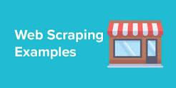

Web scraping refers to the extraction of web data on to a format that is more useful for the user. For example, you might scrape product information from an ecommerce website onto an excel spreadsheet. Although web scraping can be done manually, in most cases, you might be better off using an automated tool.

Top 8 Web Scraping Tools
- ParseHub.
- Scrapy.
- OctoParse.
- Scraper API.
- Mozenda.
- Webhose.io.
- Content Grabber.
- Common Crawl.

How do you scrape data?
How do we do web scraping?
- Inspect the website HTML that you want to crawl.
- Access URL of the website using code and download all the HTML contents on the page.
- Format the downloaded content into a readable format.
- Extract out useful information and save it into a structured format.

- KT0204 Legal issues
Web scraping and crawling aren't illegal by themselves. After all, you could scrape or crawl your own website, without a hitch. Startups love it because it's a cheap and powerful way to gather data without the need for partnerships.

Is a data scrape legal?
Web scraping is legal if you scrape data publicly available on the internet. But some kinds of data are protected by international regulations, so be careful scraping personal data, intellectual property, or confidential data. Respect your target websites and use empathy to create ethical scrapers.

Is Web scraping always legal?
Using a web scraper to harvest data off the Internet is not a criminal act on its own. Many times, it is absolutely legal to scrape a website, but the way you intend to use that data may be illegal. The legality of the process is determined by several factors, depending on a particular situation.

- KT0205 Web scraping procedure:
    - Find the URL to scrape
    - Inspect the page
    - Find the data you want to extract
    - Write the code
    - Run the code and extract the data
    - Store the data in the required format

What is scraping a URL?

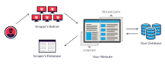

Web scraping is the process of using bots to extract content and data from a website. Unlike screen scraping, which only copies pixels displayed onscreen, web scraping extracts underlying HTML code and, with it, data stored in a database. The scraper can then replicate entire website content elsewhere.

Can you scrape any website?
Web scraping and crawling aren't illegal by themselves. After all, you could scrape or crawl your own website, without a hitch. Startups love it because it's a cheap and powerful way to gather data without the need for partnerships.

How do you inspect a website for scraping?
Inspecting the HTML of a Website
Firstly load the web page you want to scrape from. Right click on the page and select inspect. This will load the HTML of the website which shows the make-up of the website. Select the tool at the top left of the pane to highlight the code responsible for each part of the web page.

How do you scrape a website step by step?
To extract data using web scraping with python, you need to follow these basic steps:
- Find the URL that you want to scrape.
- Inspecting the Page.
- Find the data you want to extract.
- Write the code.
- Run the code and extract the data.
- Store the data in the required format.

How data is extracted from web scraping?
To extract data using web scraping with python, you need to follow these basic steps:
- Find the URL that you want to scrape.
- Inspecting the Page.
- Find the data you want to extract.
- Write the code.
- Run the code and extract the data.
- Store the data in the required format.

What type of data does web scraping extract?
Web scraping is the process of using bots to extract content and data from a website. Unlike screen scraping, which only copies pixels displayed onscreen, web scraping extracts underlying HTML code and, with it, data stored in a database. The scraper can then replicate entire website content elsewhere.

To extract data using web scraping with python, you need to follow these basic steps:
- Find the URL that you want to scrape.
- Inspecting the Page.
- Find the data you want to extract.
- Write the code.
- Run the code and extract the data.
- Store the data in the required format.

What is code scraping?
Data scraping is a technique where a computer program extracts data from human-readable output coming from another program.

What is an example of web scraping?

Web scraping refers to the extraction of web data on to a format that is more useful for the user. For example, you might scrape product information from an ecommerce website onto an excel spreadsheet. Although web scraping can be done manually, in most cases, you might be better off using an automated tool.

How data is extracted from Web scraping?
To extract data using web scraping with python, you need to follow these basic steps:
- Find the URL that you want to scrape.
- Inspecting the Page.
- Find the data you want to extract.
- Write the code.
- Run the code and extract the data.
- Store the data in the required format.

What is the process of web scraping?

Web scraping is the process of using bots to extract content and data from a website. Unlike screen scraping, which only copies pixels displayed onscreen, web scraping extracts underlying HTML code and, with it, data stored in a database. The scraper can then replicate entire website content elsewhere.

- KT0206 Libraries used for web scraping

Web scraping is the process of extracting structured and unstructured data from the web with the help of programs and exporting into a useful format. If you want to learn more about web scraping, here are a couple of resources to get you started:
- Hands-On Introduction to Web Scraping in Python: A Powerful Way to Extract Data for your Data Science Project
- FREE Course – Introduction to Web Scraping using Python
Alright – let’s see the web scraping libraries in Python!

1. Requests (HTTP for Humans) Library for Web Scraping
Let’s start with the most basic Python library for web scraping. ‘Requests’ lets us make HTML requests to the website’s server for retrieving the data on its page. Getting the HTML content of a web page is the first and foremost step of web scraping.
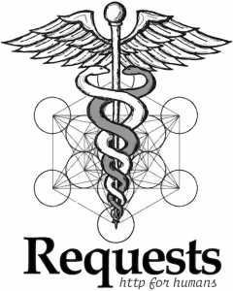
Requests is a Python library used for making various types of HTTP requests like GET, POST, etc. Because of its simplicity and ease of use, it comes with the motto of HTTP for Humans.
I would say this the most basic yet essential library for web scraping. However, the Requests library does not parse the HTML data retrieved. If we want to do that, we require libraries like lxml and Beautiful Soup (we’ll cover them further down in this article).
Let’s take a look at the advantages and disadvantages of the Requests Python library.
Advantages:
- Simple
- Basic/Digest Authentication
- International Domains and URLs
- Chunked Requests
- HTTP(S) Proxy Support
Disadvantages:
- Retrieves only static content of a page
- Can’t be used for parsing HTML
- Can’t handle websites made purely with JavaScript

2. lxml Library for Web Scraping
We know the requests library cannot parse the HTML retrieved from a web page. Therefore, we require lxml, a high performance, blazingly fast, production-quality HTML, and XML parsing Python library.
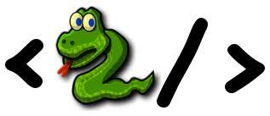
It combines the speed and power of Element trees with the simplicity of Python. It works well when we’re aiming to scrape large datasets. The combination of requests and lxml is very common in web scraping. It also allows you to extract data from HTML using XPath and CSS selectors.
Let’s take a look at the advantages and disadvantages of the lxml Python library.
Advantages:
- Faster than most of the parsers out there
- Light-weight
- Uses element trees
- Pythonic API
Disadvantages:
- Does not work well with poorly designed HTML
- The official documentation is not very beginner-friendly

3. Beautiful Soup Library for Web Scraping
BeautifulSoup is perhaps the most widely used Python library for web scraping. It creates a parse tree for parsing HTML and XML documents. Beautiful Soup automatically converts incoming documents to Unicode and outgoing documents to UTF-8.
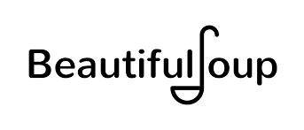
One of the primary reasons the Beautiful Soup library is so popular is that it is easier to work with and well suited for beginners. We can also combine Beautiful Soup with other parsers like lxml. But all this ease of use comes with a cost – it is slower than lxml. Even while using lxml as a parser, it is slower than pure lxml.
One major advantage of the Beautiful Soup library is that it works very well with poorly designed HTML and has a lot of functions. The combination of Beautiful Soup and Requests is quite common in the industry.
Advantages:
- Requires a few lines of code
- Great documentation
- Easy to learn for beginners
- Robust
- Automatic encoding detection
Disadvantages:
- Slower than lxml
If you want to learn how to scrape web pages using Beautiful Soup, this tutorial is for you:
- Beginner’s guide to Web Scraping in Python using Beautiful Soup

4. Selenium Library for Web Scraping
There is a limitation to all the Python libraries we have discussed so far – we cannot easily scrape data from dynamically populated websites. It happens because sometimes the data present on the page is loaded through JavaScript. In simple words, if the page is not static, then the Python libraries mentioned earlier struggle to scrape the data from it.
That’s where Selenium comes into play.
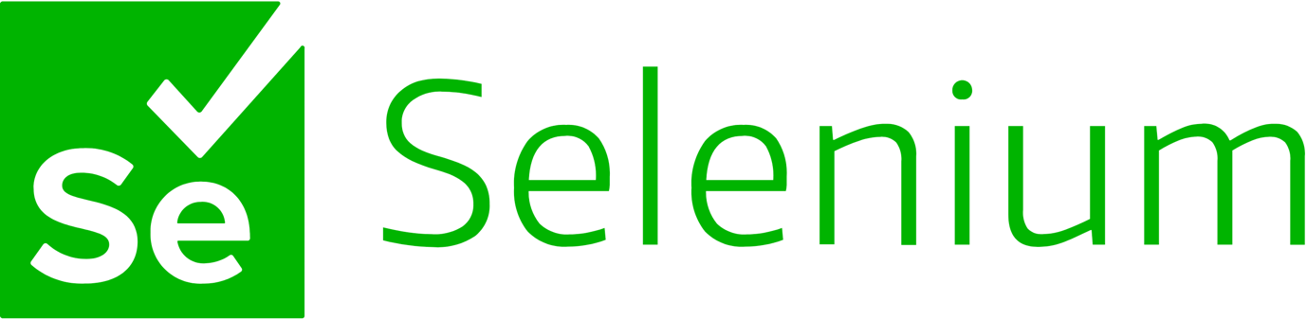
Selenium is a Python library originally made for automated testing of web applications. Although it wasn’t made for web scraping originally, the data science community turned that around pretty quickly!
It is a web driver made for rendering web pages, but this functionality makes it very special. Where other libraries are not capable of running JavaScript, Selenium excels. It can make clicks on a page, fill forms, scroll the page and do many more things.
This ability to run JavaScript in a web page gives Selenium the power to scrape dynamically populated web pages. But there is a trade-off here. It loads and runs JavaScript for every page, which makes it slower and not suitable for large scale projects.
If time and speed is not a concern for you, then you can definitely use Selenium.
Advantages:
- Beginner-friendly
- Automated web scraping
- Can scrape dynamically populated web pages
- Automates web browsers
- Can do anything on a web page similar to a person
Disadvantages:
- Very slow
- Difficult to setup
- High CPU and memory usage
- Not ideal for large projects
Here is a wonderful article to learn how Selenium works (including Python code):
- Data Science Project: Scraping YouTube Data using Python and Selenium to Classify Videos

Internal Assessment Criteria and Weight

- IAC0201The principles and purpose of data scraping are explained
- IAC0202Web scraping applications are created in languages such as Python or Java to help bring data into a variety of AI applications

Good Luck!!

